RESULTS AND OUTCOME

5.1 Overview
The RADMAP project successfully demonstrated the feasibility of a GPS-enabled real-time radiation mapping system using Raspberry Pi-5 integrated with a Gamma Spectrometer, GlobalSat BU-353N GPS Receiver, environmental sensors, and live camera monitoring. Throughout the internship, a complete backend pipeline was developed to collect, process, visualize, and analyze radiation data in real time.
One of the primary achievements was the successful development of a 2D radiation heatmap, where radiation intensity was accurately mapped using GPS coordinates. The system displayed radiation levels through dynamic color gradients, enabling quick identification of radiation hotspots while simultaneously presenting radiation counts, peak channels, and environmental parameters such as temperature and humidity.
To address the limitation of conventional 2D mapping, a 3D Digital Twin was researched and developed by integrating GPS coordinates, SLAM-based mapping, and live camera feedback. This provided a more intuitive spatial representation of radiation distribution and established the foundation for future radioactive source localization.
The Gamma Spectrometer (CNSPEC MCA) was successfully integrated with the Raspberry Pi-5 and experimentally validated using Cobalt-60 (Co-60) and Cesium-137 (Cs-137) radioactive sources. The detector accurately identified radiation counts, peak channels, and energy spectra, confirming the reliability of the developed system.
A real-time backend architecture was implemented to synchronize radiation data, GPS information, environmental parameters, and camera streams into a unified processing pipeline. This backend ensures efficient data acquisition, storage, and visualization while supporting future AI and autonomous navigation capabilities.
Additionally, a color grading algorithm inspired by night-vision imaging was developed to overlay radiation intensity on live camera footage. Different radiation levels were represented using multiple color gradients, significantly improving real-time visualization and situational awareness.
Finally, a 3D prototype model of the RADMAP system was designed for future deployment. Based on the successful outcomes of the project, the work received funding approval from Dr. Abhishek Yadav and the Director, Amity Institute of Nuclear Science and Technology (AINST) for further enhancement, hardware integration, and next-generation development.

5.2 Prototype Implementation
The final RADMAP prototype combines all major hardware components into a compact and portable system. It performs real-time acquisition of radiation counts, GPS coordinates, temperature, humidity, and environmental information. The collected data are processed by the Raspberry Pi-5 backend to generate synchronized radiation maps and support Digital Twin visualization.
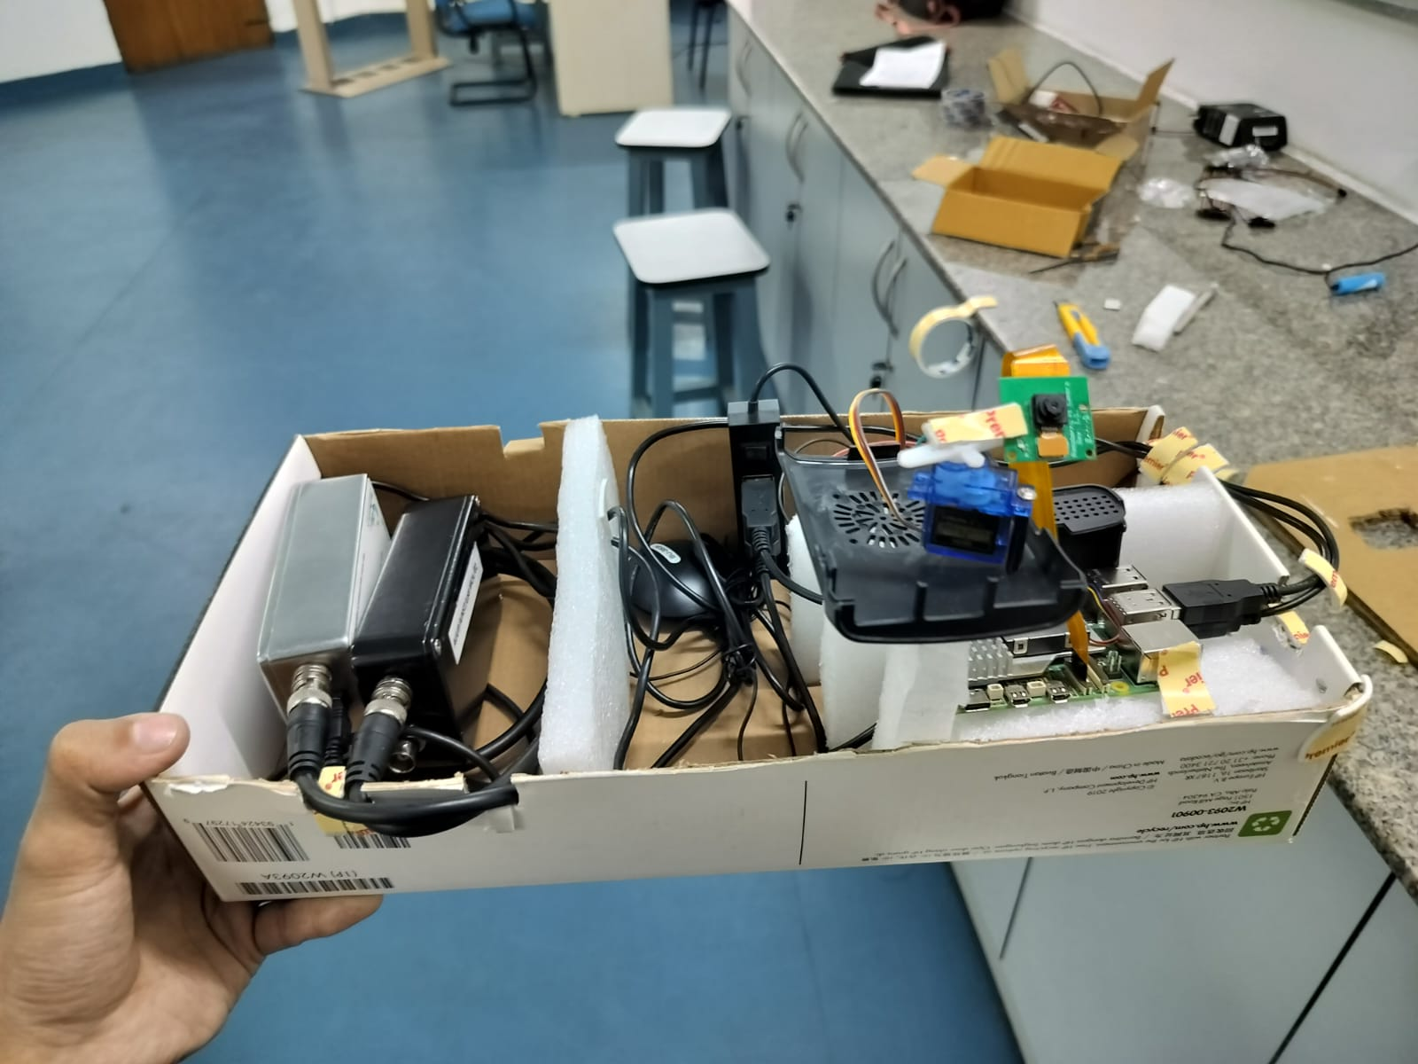
Figure 9: Final RADMAP Prototype Model

5.3 GPS Data Acquisition Results
The GlobalSat ‘BU-353N’ GPS Receiver successfully provided continuous geographical positioning and environmental telemetry during system operation. The acquired GPS information was synchronized with radiation measurements to generate accurate geospatial radiation maps. The GlobalSat BU-353N GPS Receiver was successfully integrated with the Raspberry Pi-5 to acquire real-time geographical positioning data. The system continuously collected latitude, longitude, UTC time, satellite information, speed, and positioning accuracy (HDOP/PDOP) through NMEA communication.
Parameter | Observed Value
GPS Receiver | GlobalSat BU-353N
Communication Port | COM8 (Prolific PL2303GC USB Serial)
Baud Rate | 4800 bps
Date | 18th June, 2026
UTC Time | 12:37:50
Latitude | 28° 32.7622′ N
Longitude | 77° 19.9810′ E
GPS Fix Status | 3D Fix
Speed | 1km/h
Direction (Course) | 77.99°
Satellites in View | 10
Satellites in Used | 5
HDOP | 1.57
PDOP | 1.85
Data Protocol | NMEA 0183 (GPGGA, GPRMC, GPGSV, GPGSA)
Communication Interface | USB Serial (PL2303GC)

Table 3: Real-Time GPS Receiver Output (GlobalSat BU-353N)

6.4 Final Integrated System Metrics
The integrated system successfully synchronized radiation measurements with GPS coordinates and environmental parameters. These combined metrics were used to generate the 2D radiation heatmap and support the 3D Digital Twin visualization.
Parameter | Value
Source | Cobalt-60 (Co-60)
Device (Status) | LIVE
Elapsed Duration | 38S
Total Counts | 3,935
Radiation Intensity (Area) | 3,935
Count Rate | 103.6 CPS
Peak Channel | 92
Max Counts (at Peak) | 45

Table 4: Session Summary of Gamma Spectrometer

Channel Number | Count | Relative Prominence
92 | 45 | Primary Photo peak
127 | 27 | Secondary
148 | 24 | Secondary
168 | 19 | Minor
190 | 11 | Minor
212 | 13 | Minor
240 | 26 | Secondary
274 | 13 | Minor

Table 5: Detected Photo peaks (Channel-wise) of Gamma Spectrometer

